# COMPILER LAB 2 ASSIGNMENT

*def* PDA():

    s=input("Enter String for Given CFG{0,1} :")

    n=len(s)

    stack=[]

    state=0

    i=0

    while(i<n and state==0):

        if (s[i]=='0'):

            stack.append(s[i])

        else:

            state=1

            break

        i+=1

    while(i<n and state==1 and len(stack)!=0):

        if (s[i]=='1'):

            stack.pop()

            if (i==n-1 and len(stack)==0):

                state=2

                break

        else:

            break

        i+=1

    if (state==2):

        print("Given CFG is accepted by PDA",s," : ",state)

    else:

        print("CFG is rejected by PDA at state ",s," : ",state)

PDA()

*def* pda2():

    string=input("Enter String for CFG over {0,1} : ")

    stack=[]

    state="q0"

    for item in string:

        if (item=='0'):

            if (len(stack)==0):

                stack.append('0')

            elif (stack[-1]=='0'):

                stack.append('0')

            elif (stack[-1]=='1'):

                stack.pop()

        elif (item=="1"):

            if (len(stack)==0):

                stack.append('1')

            elif (stack[-1]=='1'):

                stack.append('1')

            elif (stack[-1]=='0'):

                stack.pop()

    print(stack)

    if (len(stack)==0):

        state="qf"

    if (state=="qf"):

        print("Input CFG is accepted by this PDA {string} at state : ",state)

    elif (state=="q0"):

        print("Input CFG is rejected by this PDA {string} at state : ",state)

pda2()

## PART 1 PDA OUTPUT:

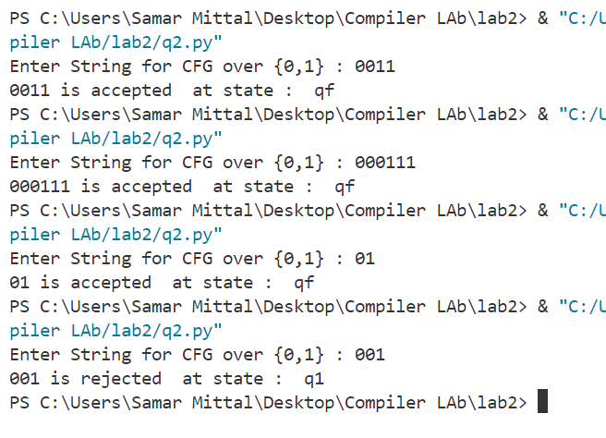

## PART 3 PDA OUTPUT:

